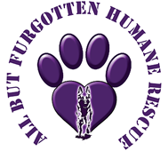
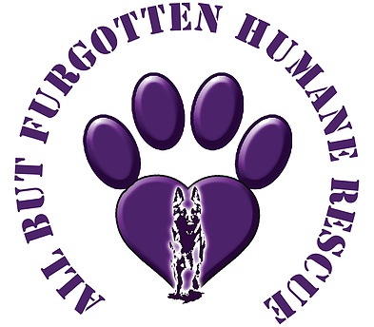
All But Furgotten
Golf Fore Pawz II
Golf Outing Registration
Company Information
Company: _____________________________________________
Company Phone Number: (_____) _____ - ________
Company Contact: _________________________________________
Contact E-mail Address: ____________________________________
Early Bird Registration (By COB April 30, 2024) Individual - $110 Foursome - $440

Registration (after May 1, 2024 ) Individual - $110 Foursome - $440 Dinner Only - $30

______________________________PAYMENT DUE BY JUNE 30, 2024 ______________________________
Attendees Name(s) Phone#: E-mail Address
- _________________________________________ ____________________________________________
- _________________________________________ ____________________________________________
- _________________________________________ ____________________________________________
- _________________________________________ ____________________________________________
- _________________________________________ ____________________________________________
- _________________________________________ ____________________________________________
- _________________________________________ ____________________________________________
- _________________________________________ ____________________________________________
Total Amount Due: _______________
Payment Information
Check Online Payment
Pay

Check Payment may be mailed to All But Furgotten c/o Patricia Marciniec 1341 Samantha Way North Huntingdon PA 15642. Please insert a copy of completed registration form with your check.

Online payment, please email a copy of completed registration form to Patricia Marciniec at pmarciniec@comcast.net.

Once registration forms are received, Patty will confirm the registration.

The animals, All But Furgotten and Golf Event Committee thank you!!!!

